Sustainable Intensification

## SQ1: Is farming with Silvopastoral Systems in Caquetá a from of Sustainable Intensification?

library(tidyverse) # loading R packages  
library(ggplot2)  
load("Dataframes/si.df.rda") # Load Dataframe  
si.df <- filter(si.df, land_type=="Lomerío (lomas, mesas y vallecitos" & SPS!="NA") # filtering data to only contain farms on landscape "hills" and missing responses for SPS

### Creating Scatterplotts

ggplot(data = si.df)+  
 geom_point(mapping = aes(x=milkperhectare, y= distance, colour=SPS))

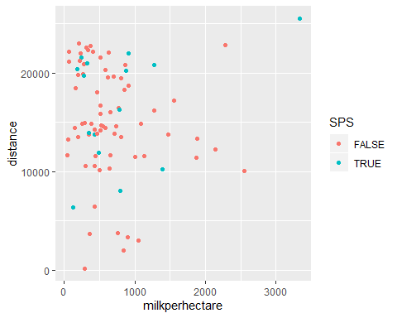

ggplot(data = si.df)+  
 geom_point(mapping = aes(x=labourperhectare, y= stocking_rate, colour=SPS))

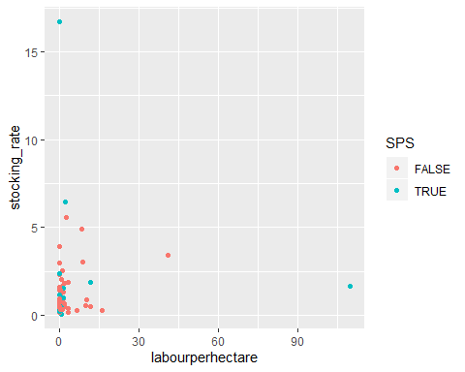

**Stocking rates**

### Histograms and Q-Q plots for stocking rates of farmers without and with SPS

par(mfrow=c(2,2))  
hist(si.df$stocking_rate[si.df$SPS==FALSE],breaks = 60, main="farmers without SPS")  
qqnorm(si.df$stocking_rate[si.df$SPS==FALSE], ylim = c(0,6))  
qqline(si.df$stocking_rate[si.df$SPS==FALSE], ylim = c(0,6))  
hist(si.df$stocking_rate[si.df$SPS==TRUE],breaks = 15, main="farmers with SPS")  
qqnorm(si.df$stocking_rate[si.df$SPS==TRUE], ylim = c(0,6))  
qqline(si.df$stocking_rate[si.df$SPS==TRUE], ylim = c(0,6))

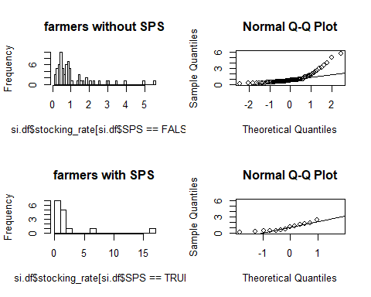

### Log-transformation of stocking rates

si.df$stocking_rate.log <- log(si.df$stocking_rate)

### Histograms and Q-Q plots of log-stocking rates

par(mfrow=c(2,2))  
hist(si.df$stocking_rate.log[si.df$SPS==FALSE], breaks = 60, main = "farmers without SPS")  
qqnorm(si.df$stocking_rate.log[si.df$SPS==FALSE], ylim = c(-3,3))  
qqline(si.df$stocking_rate.log[si.df$SPS==FALSE], ylim = c(-3,3))  
hist(si.df$stocking_rate.log[si.df$SPS==TRUE], breaks = 15, main="farmers with SPS")  
qqnorm(si.df$stocking_rate.log[si.df$SPS==TRUE], ylim = c(-3,3))  
qqline(si.df$stocking_rate.log[si.df$SPS==TRUE], ylim = c(-3,3))

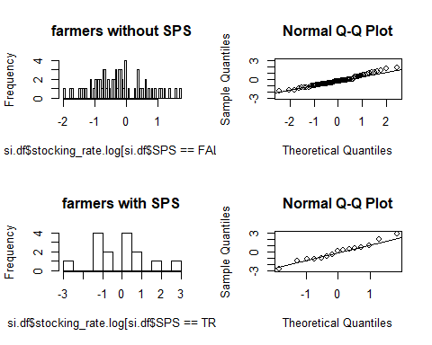

### Boxplots of stocking rates of farmers without and with SPS

ggplot(data=si.df)+  
 geom_boxplot(mapping = aes(y=stocking_rate.log, x=SPS))

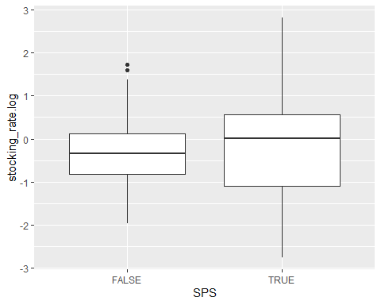

### Two-sided t-test of means of log-stocking rates of farmers without and with SPS

stock.t_test <- t.test(  
 x=si.df$stocking_rate.log [si.df$SPS==FALSE],  
 y=si.df$stocking_rate.log [si.df$SPS==TRUE])  
stock.t_test

##   
## Welch Two Sample t-test  
##   
## data: si.df$stocking_rate.log[si.df$SPS == FALSE] and si.df$stocking_rate.log[si.df$SPS == TRUE]  
## t = -0.48169, df = 16.172, p-value = 0.6365  
## alternative hypothesis: true difference in means is not equal to 0  
## 95 percent confidence interval:  
## -0.9701064 0.6106179  
## sample estimates:  
## mean of x mean of y   
## -0.2865579 -0.1068137

### Transformation of means of log-stocking rates back to level

exp(stock.t_test$estimate)

## mean of x mean of y   
## 0.7508436 0.8986931

Conventional farmers have a mean stocking rate of 0.7508436. SPS farmers have a mean stocking rate of 0.8986931. Even though the mean stocking rates (geometric means) of SPS farmers are higher they don’t differ significantly. The Null-hypotheses (both means are the same) can not be rejected.

**Annual milk yield per hectare**

### Histograms and Q-Q plots of milk yields of farmers without and with SPS

par(mfrow=c(2,2))  
hist(si.df$milkperhectare[si.df$SPS==FALSE],breaks = 70, main="farmers without SPS")  
qqnorm(si.df$milkperhectare[si.df$SPS==FALSE], ylim = c(-0,2500))  
qqline(si.df$milkperhectare[si.df$SPS==FALSE], ylim = c(-0,2500))  
hist(si.df$milkperhectare[si.df$SPS==TRUE],breaks = 15, main="farmers with SPS")  
qqnorm(si.df$milkperhectare[si.df$SPS==TRUE], ylim = c(-0,2500))  
qqline(si.df$milkperhectare[si.df$SPS==TRUE], ylim = c(-0,2500))

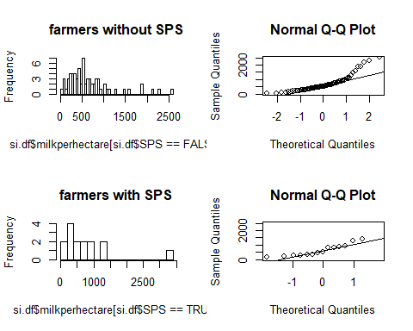

### Log-transformation of milk yields

si.df$milkperhectare.log <- log(si.df$milkperhectare)

### Histograms and Q-Q plots of log-milk yields

par(mfrow=c(2,2))  
hist(si.df$milkperhectare.log[si.df$SPS==FALSE], breaks = 70, main = "farmers without SPS")  
qqnorm(si.df$milkperhectare.log[si.df$SPS==FALSE], ylim = c(4,8))  
qqline(si.df$milkperhectare.log[si.df$SPS==FALSE], ylim = c(4,8))  
hist(si.df$milkperhectare.log[si.df$SPS==TRUE], breaks = 15, main="farmers with SPS")  
qqnorm(si.df$milkperhectare.log[si.df$SPS==TRUE], ylim = c(4,8))  
qqline(si.df$milkperhectare.log[si.df$SPS==TRUE], ylim = c(4,8))

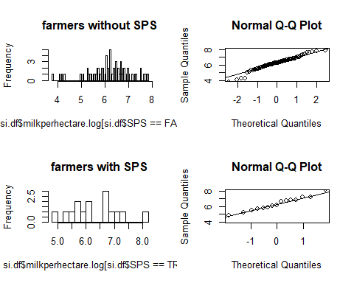

### Boxplots of log milk yield

ggplot(data=si.df)+  
 geom_boxplot(mapping = aes(y=milkperhectare.log, x=SPS))

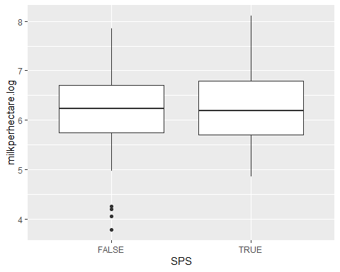

### T-test comparing mean milk yields per hectare of farmers with and without SPS

my.t_test <- t.test(  
 x=si.df$milkperhectare.log[si.df$SPS==FALSE],  
 y=si.df$milkperhectare.log[si.df$SPS==TRUE])  
my.t_test

##   
## Welch Two Sample t-test  
##   
## data: si.df$milkperhectare.log[si.df$SPS == FALSE] and si.df$milkperhectare.log[si.df$SPS == TRUE]  
## t = -0.4109, df = 20.246, p-value = 0.6855  
## alternative hypothesis: true difference in means is not equal to 0  
## 95 percent confidence interval:  
## -0.6136649 0.4115578  
## sample estimates:  
## mean of x mean of y   
## 6.200096 6.301150

### Transformation of means of log-milk yields back to level

exp(my.t_test$estimate)

## mean of x mean of y   
## 492.7965 545.1984

The two-sided t-test shows a higher annual mean milk yield per hectare for SPS farmers. However results are not significant as the Null-hypothesis cannot be rejected.

**Annual labour days per hectare**

### Histograms and Q-Q plot of labour days of farmers without and with SPS

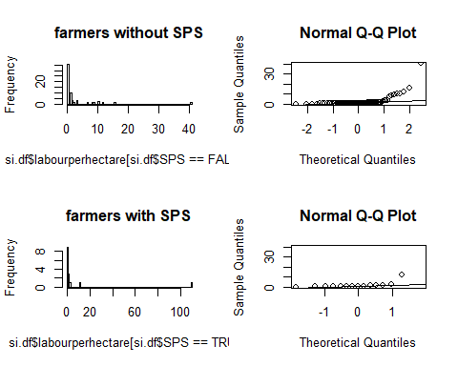

### Log-transformation of labour days

si.df$labourperhectare.log <- log(si.df$labourperhectare+0.01)

### Histograms and Q-Q plots of log-labour days

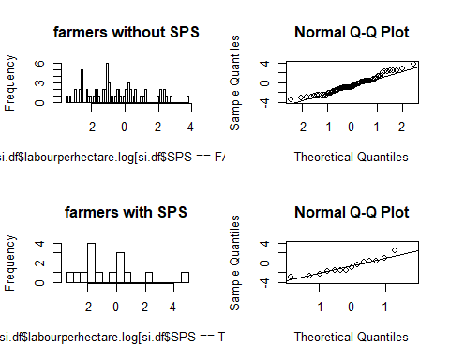

### Boxplot of labour days

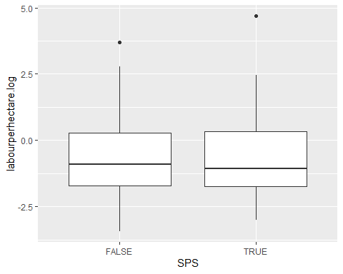

### T-test comparing mean labour hours per hectare of farmers without and with SPS

lh.t_test <- t.test(  
 x=si.df$labourperhectare.log[si.df$SPS==FALSE],  
 y=si.df$labourperhectare.log[si.df$SPS==TRUE])  
lh.t_test

##   
## Welch Two Sample t-test  
##   
## data: si.df$labourperhectare.log[si.df$SPS == FALSE] and si.df$labourperhectare.log[si.df$SPS == TRUE]  
## t = -0.13306, df = 17.937, p-value = 0.8956  
## alternative hypothesis: true difference in means is not equal to 0  
## 95 percent confidence interval:  
## -1.272137 1.120631  
## sample estimates:  
## mean of x mean of y   
## -0.5760283 -0.5002750

### Transformation of means of log-labour days back to level

exp(lh.t_test$estimate)-0.01

## mean of x mean of y   
## 0.5521266 0.5963639

Mean annual labour days per hectare are slightly higher for SPS farmers than for conventional farmers. The difference however is not significantly high enough to reject the NUll-hypothesis of both means beeing equal.

**Distance to highway**

### Histograms and Q-Q plots of distance of farmers without and with SPS

par(mfrow=c(2,2))  
hist(si.df$distance[si.df$SPS==FALSE],breaks = 70, main="farmers without SPS")  
qqnorm(si.df$distance[si.df$SPS==FALSE], ylim = c(-0,25000))  
qqline(si.df$distance[si.df$SPS==FALSE], ylim = c(-0,25000))  
hist(si.df$distance[si.df$SPS==TRUE],breaks = 15, main="farmers with SPS")  
qqnorm(si.df$distance[si.df$SPS==TRUE], ylim = c(-0,25000))  
qqline(si.df$distance[si.df$SPS==TRUE], ylim = c(-0,25000))

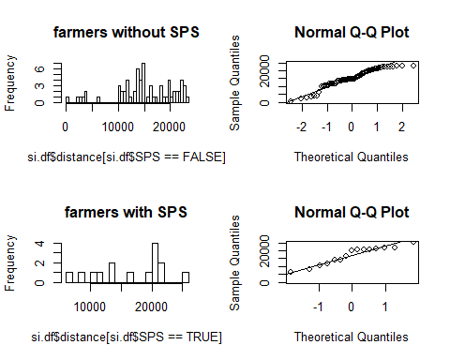

### Boxplots of distance

ggplot(data=si.df)+  
 geom_boxplot(mapping = aes(y=distance, x=SPS))

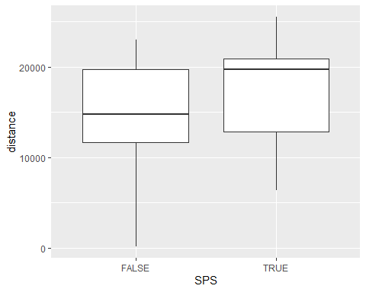

### T-test comparing mean distance of farmers without and with SPS

d.t_test <- t.test(  
 x=si.df$distance[si.df$SPS==FALSE],  
 y=si.df$distance[si.df$SPS==TRUE])  
d.t_test

##   
## Welch Two Sample t-test  
##   
## data: si.df$distance[si.df$SPS == FALSE] and si.df$distance[si.df$SPS == TRUE]  
## t = -1.0514, df = 20.245, p-value = 0.3055  
## alternative hypothesis: true difference in means is not equal to 0  
## 95 percent confidence interval:  
## -5120.033 1686.631  
## sample estimates:  
## mean of x mean of y   
## 15055.63 16772.33

The mean distance indicates that SPS farmers are located a little further from the highway. Again however the difference is not significant enough to reject the Null-hypothesis that both means are the same.